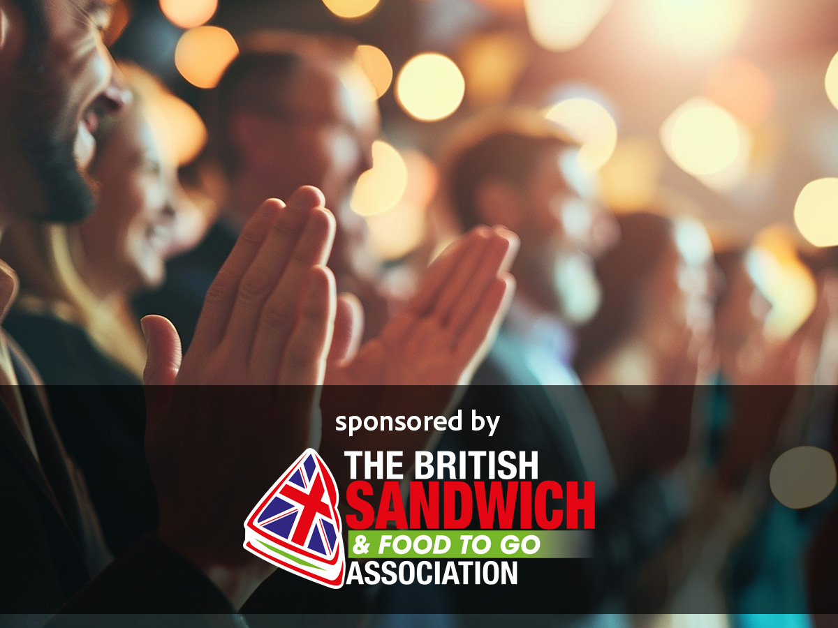**Award Qualifying Period**

1 March 2024 to   
28 February 2025

**Closing Date**

5 February 2025

This lifetime achievement award is in the gift of the British Sandwich & Food to Go Association  Management Committee and is special recognition of the recipients’ contribution to the industry.

If you would like to nominate someone for this award, please send us your nomination explaining why the nominee deserves to win.

**Your Details**

**Contact Name:**

**Position:**

**Business Name:**

**Address:**

**Postcode:**

**Business Tel:**

**Mobile:**

**Contact E-Mail:**

|  |
| --- |
| Please provide your written submission here and why your nominee deserves to win the award.  Other supporting material may be sent together with your entry |
| Nominee:  Your reasons: |